Paper Title | Link | Summary | Insights
Non-contact Atrial Fibrillation Detection from Face Videos by Learning Systolic Peaks- |  | Their model achieves 96% accuracy in distinguishing healthy v Atrial Fibrillation. The key methodology difference is using the systolic peaks to train. They use a binary method to encode it:  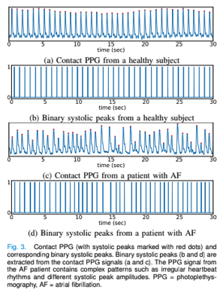  Broadly speaking, they use OpenFace to get landmarks of face, crop to 1.2x this, resize to 128x128. Then pass into their 3DCNN model, which outputs remote PPG. Then pass into SVM classifier which classifies as AF or healthy,]. | While 96 seems high, not sure it is high enough. Given the estimate of AF in population of around 2% in 100,000 people. This uses their reported 95.36% and 96.12% sensitivity and specificity respectively.  By these numbers, if a random person was classified as having AF, they have a 33% chance of actually having AF.
   | Test Positive | Test Negative
  True Positive | 1907 | 93 | 2,000
  True Negative | 3802 | 94198 | 98,000
   | 5709 | 94291 | 100,000
Motion-Robust Atrial Fibrillation Detection Based on Remote-Photoplethysmography |  | Focus on adding motion-robustness. Discussion of light-based noise which is typically but not always caused by utility power, i.e ~60Hz
Contactless facial video recording with deep learning models for the detection of atrial fibrillation |  | Using 84FPS camera on 473 participants, then used face detection to get ROI. Used a bandpass filter (fourth order Cheyshev II cutoff 0.5-3Hz) to smooth.  This study specifically expanded on AF detection to differentiate from other arrhythmia.
Deep Learning Classifier for Advancing Video Monitoring of Atrial Fibrillation |  | Compares how the model performs compared to other common methods such as ECG. The model is also trained on 4 methods, ECG, PPG, rPPG 180Hz and rPPG 30Hz.  Model performed strongly, can see that a 30Hz camera performed slightly better to 180Hz. | Commonly used HRV features include Root Mean Square  of Successive Differences (RMSSD), Standard Deviation of  NN-intervals (SDNN) and The proportion of the number of  pairs of successive beat to beat intervals that differ by more  than 50 milliseconds (pNN50)  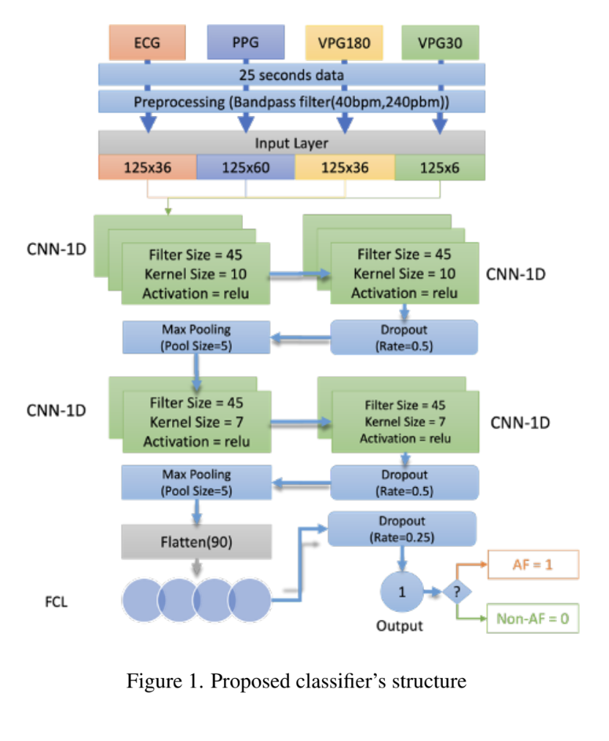  This model does not do any feature extraction, the region of interest (ROI) is the face and patients were still during recording of cameras.
The Current State of Mobile Phone Apps for Monitoring Heart  Rate, Heart Rate Variability, and Atrial Fibrillation: Narrative  Review |  | Review of mobile phone apps. Includes ecg that can connect to phone, using phone’s flashlight + camera to do photoplesmography. Concludes that phone-based applications have a place in future and identifies areas of further study and potential limitations, such as patients having different phones and legal complications.
AI-enabled remote monitoring of vital signs for COVID-19: methods, prospects and challenges | https://link.springer.com/content/pdf/10.1007/s00607-021-00937-7.pdf
Remote Photoplethysmography for Heart  Rate and Blood Oxygenation  Measurement: A Review | Remote_Photoplethysmography_for_Heart_Rate_and_Blood_Oxygenation_Measurement_A_Review-2.pdf | A good and recent (published June 24) review of the current state of remote photoplethysmography.  Discusses various steps:  ROI: manual, Viola and Jones, KLT, Openface, MTCNNS
 | https://ieeexplore.ieee.org/document/10784985
Color Signal Processing Methods for Webcam-Based Heart Rate Evaluation | https://www.semanticscholar.org/paper/Color-Signal-Processing-Methods-for-Webcam-Based-Kopeliovich-Petrushan/a45078ac942045a3c951a7ee17690a20e6d2cf80  Aydan has download | This paper goes over different signal processing methods for rPPG in detecting and evaluating hear rate. | 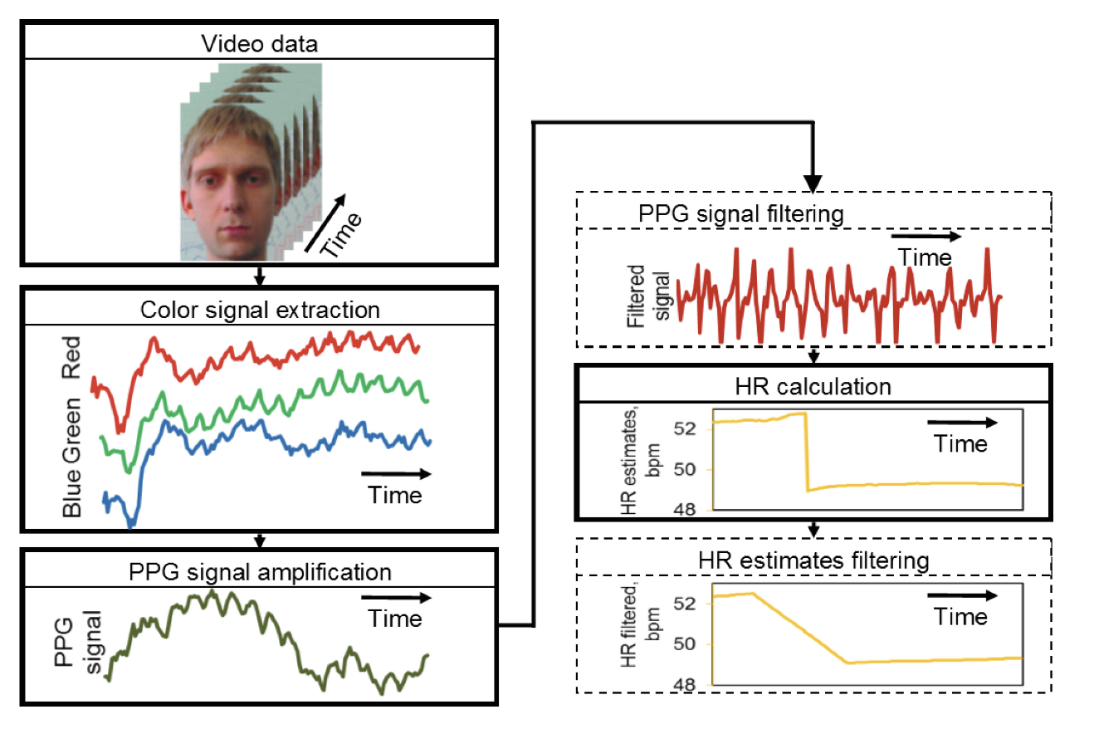  rPPG can also be conducted by detecting low-amplitude head motions  The optimal areas from which to extract PPG signal are between the eyes and below the eyes, on the upper parts of the cheeks.  Not only rigid motions (head rotations, translations and tilts) but also non-rigid motions (facial expressions) can make the PPG signal much worse
Heart rate estimation in PPG signals using Convolutional-Recurrent Regressor | https://www.sciencedirect.com/science/article/pii/S0010482522002621 | The paper looks into utilising a CNN for extracting heart rate signals. | Definitely seems that a CNN will be the way of the future for extracting HR data thanks to its ability to account for noise such as motion artefacts.
Photoplethysmographic Time-Domain Heart Rate Measurement Algorithm for Resource-Constrained Wearable Devices and its Implementation | https://pmc.ncbi.nlm.nih.gov/articles/PMC7146569/ | Outlines the methodology for extracting HR from a PPG signal. Although PPG many techniques are applicable to the RPPG
A Novel Algorithm for Remote Photoplethysmography: Spatial Subspace Rotation | https://ieeexplore.ieee.org/document/7355301 | Introduces a new method called spatial subspace rotation (2SR) that is used to get the pulse signal from the RGB signal. | The experimental results show that given a well-defined skin mask, 2SR outperforms the popular ICA-based approach and two state-of-the-art algorithms (CHROM and PBV). When comparing the pulse frequency spectrum, 2SR improves on average the SNR of ICA by 2.22 dB, CHROM by 1.56 dB, and PBV by 1.95 dB. When comparing the instant pulse-rate, 2SR improves on average the Pearson correlation and precision of ICA by 47% and 65%, CHROM by 22% and 23%, and PBV by 21% and 39%. ANOVA confirms the significant improvement of 2SR in peak-to-peak accuracy.
Robust Heart Rate Variability Measurement from Facial Videos | https://pmc.ncbi.nlm.nih.gov/articles/PMC10376629/#sec2-bioengineering-10-00851 | This paper presents a novel contactless HRV extraction algorithm, WaveHRV, based on the Wavelet Scattering Transform technique, followed by adaptive bandpass filtering and inter-beat-interval (IBI) analysis to get HRV. | Peaks of the reconstructed signal are detected with the automatic multiscale-based peak detection (AMPD) [19] algorithm and inter-beat-intervals (IBIs) are calculated. Then, refined IBIs are calculated by removing physically impossible regions or misplaced peaks and retaining only those IBIs that satisfy the criteria below:  ∀IBI ∈ [400 ms, 1300 ms] **  ∀IBI ∈ mean(IBI) ± 0.4mean(IBI)  Non-overlapping window is slid over IBIs with window size 10. IBIs in each window should satisfy ∀IBIwindow ∈ mean(IBIwindow) ± 0.2mean(IBIwindow).  ** The boundaries for the IBIs should be chosen based on the task. In this research, we estimate the HRV of adults in a seated position.  AMPD is a peak detection method that might be better suited to this task.
Effectiveness of Remote PPG Construction Methods: A Preliminary Analysis | https://pmc.ncbi.nlm.nih.gov/articles/PMC9598377/ | Looks at different ways to extract the PPG signal from rPPG, 2SR not in here but others are.

